**PIZZA SALES SQL QUERIES**

**1. Total Revenue:**

SELECT SUM(total_price) AS Total_Revenue FROM pizza_Sales;

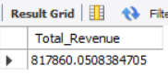

**2. Average Order Value**

SELECT SUM(total_price)/count(distinct order_id) AS Avarage_order_value FROM pizza_sales;

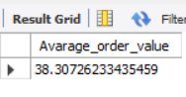

**3. Total Pizza Sold:**

SELECT SUM(quantity) AS Total_Sold FROM pizza_sales;

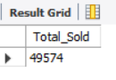

**4. Total Order Placed:**

SELECT COUNT(distinct order_id) AS Total_Order FROM pizza_sales;

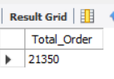

**5. Average Pizza per Order:**

SELECT sum(quantity) / count(distinct order_id) from pizza_sales;

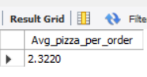

**6. Daily trend for total order:**

SELECT DAYNAME(order_date) AS order_day, COUNT(DISTINCT order_id) AS Total_orders

FROM pizza_sales

GROUP BY DAYNAME(order_date);

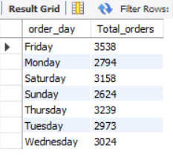

**6. Monthly trend for total order:**

SELECT MONTHNAME(order_date) AS Month_Name, COUNT(DISTINCT order_id) AS total_orders FROM pizza_sales GROUP BY MONTHNAME(order_date) ORDER BY total_orders DESC;

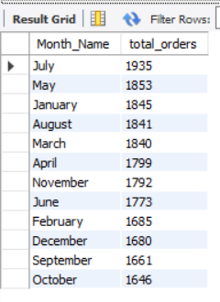

**6. Percentage of sales by pizza category:**

SELECT pizza_category, sum(total_price) * 100 / ( select sum(total_price) from pizza_sales) as total_sales

from pizza_sales group by pizza_category;

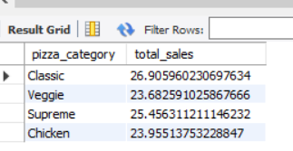

**6. Percentage of sales by pizza Size:**

SELECT pizza_size, cast( sum(total_price) * 100 / ( select sum(total_price) from pizza_sales) as decimal(10,2) )as total_sales

from pizza_sales group by pizza_size;

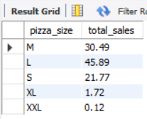

**6. Top 5 best seller by total Revenue:**

SELECT pizza_name, SUM(total_price) AS total_revenue

FROM pizza_sales

GROUP BY pizza_name

ORDER BY total_revenue DESC

LIMIT 5;

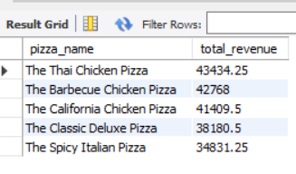

**6. Bottom 5 best seller by total Revenue:**

SELECT pizza_name, SUM(total_price) AS total_revenue

FROM pizza_sales

GROUP BY pizza_name

ORDER BY total_revenue ASC

LIMIT 5;

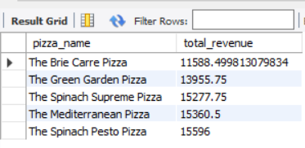

**6. Top 5 best seller by total quantity:**

SELECT pizza_name, SUM(quantity) AS total_quantity

FROM pizza_sales

GROUP BY pizza_name

ORDER BY total_quantity DESC

LIMIT 5;

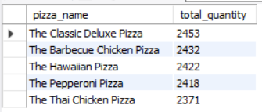

**6. Bottom 5 best seller by total quantity:**

SELECT pizza_name, SUM(quantity) AS total_quantity

FROM pizza_sales

GROUP BY pizza_name

ORDER BY total_quantity ASC

LIMIT 5;

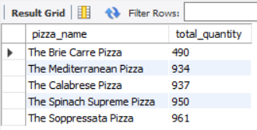

**6. TOP 5 best seller by total orders:**

SELECT pizza_name, COUNT(DISTINCT order_id) AS total_order

FROM pizza_sales

GROUP BY pizza_name

ORDER BY total_order DESC

LIMIT 5;

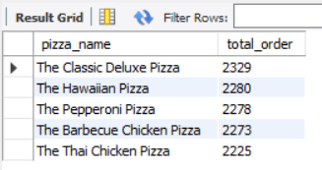

**6. Bottom 5 best seller by total orders:**

SELECT pizza_name, COUNT(DISTINCT order_id) AS total_order

FROM pizza_sales

GROUP BY pizza_name

ORDER BY total_order ASC

LIMIT 5;

